1. **Input:**

x=001;

Output

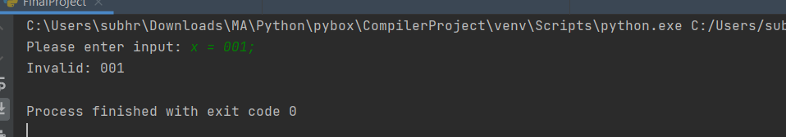

1. **Input:**

x_2 = 0;

Output

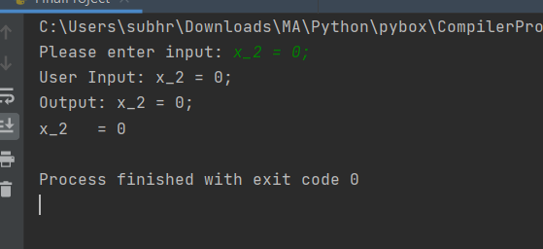

1. **Input:**

x = 0 y = x; z = ---(x+y);

Output

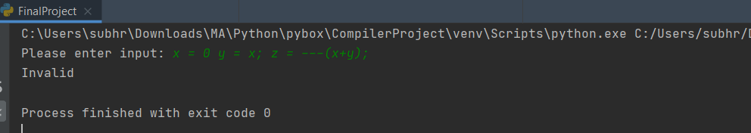

1. **Input:**

x = 1; y = 2; z = ---(x+y) *(x+-y);

output

